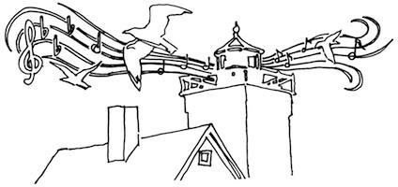
Two Harbors Community Radio
Program Proposal for KTwH-LP 99.5 FM
THCR/KTWH is open to new program proposals from anyone with an idea to pitch.
Please answer as many of the questions below as you can, but if you don’t have all the answers at this point, not to worry, we can work out details when needed.
The only required questions are those with an asterisk*

*Program concept – what kind of program? (use the back of the form if you need more room)
Do you have a name for the program?
How long would the program last? How often would it program air?
[how many minutes/hours] [daily/weekly/monthly/other?]
Is there a time of day and/or day of the week that would be preferable for this program?
Do you imagine it being done live or pre-recorded?
Do you have any broadcasting training and/or experience? If so, please explain NOTE: These are not required at all, just curious. We can train you.
*Name and contact information (one or more means of contact)
Name: Date
Phone:
Email:
Address:

PO Box 622, Two Harbors, MN 55616 218-834-2247 THCommRadio@gmail.com

